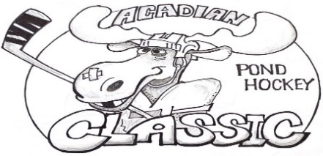 2023 Registration Form

Team Name: ______________________________
JR. Division: Ages 15-17
Roster: Max of 5, Min of 3 players
1.________________________________ Age______ (Team Captain)
2. _______________________________ Age______
3. _______________________________ Age______
4. _______________________________ Age______
5. _______________________________ Age______
Adult Contact Information:
Phone Number: _______________________
Email Address: ________________________
Cost is $125 USD

E-mail this completed form to acadianpondhockey@gmail.com to receive payment link or mail this form and check (payable to Acadian Pond Hockey Classic) to 135 Green Point Rd, Saint David, ME 04773
Adult’s signature below acknowledges that organizers of the tournament are not responsible for injuries to players as all players are to play at their own risk.
X___________________________________

